Project code in text file

Geu badminton tournament



Codes

Submitted to:

Mr rishi kumar

Ass. Professor

1} #include <stdio.h>

int main() {

char name[50];

int age;

printf("Enter your name: ");

scanf("%s", name);

printf("Enter your age: ");

scanf("%d", &age);

if (age >= 18 && age <= 25) {

printf("Welcome, %s!\n", name);

printf("Entry fees: Rs 250\n");

// Collect entry fees (assuming payment process here)

printf("Thank you for participating!\n");

} else {

printf("Sorry, you are not eligible to participate.\n");

}

return 0;

}

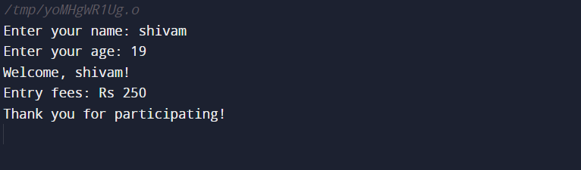

2}#include <stdio.h>

int main() {

char menu[20][50];

for (int day = 0; day < 20; day++) {

printf("Enter the menu for Day %d: ", day + 1);

scanf("%s", menu[day]);

}

printf("\nMenu for 20 days:\n");

for (int day = 0; day < 20; day++) {

printf("Day %d: %s\n", day + 1, menu[day]);

}

return 0;

}

3}#include <stdio.h>

int main() {

int badmintonRacketsPerMatch = 2;

int shuttlecocksPerMatch = 6;

int pairsOfShoesPerMatch = 2;

int totalEquipment = badmintonRacketsPerMatch + shuttlecocksPerMatch + (pairsOfShoesPerMatch \* 2);

printf("Total number of badminton equipment needed for a match: %d\n", totalEquipment);

return 0;

}

4}#include <stdio.h>

int main() {

int choice;

printf("Welcome to the Badminton Tournament!\n");

printf("Enter the type of sponsor:\n");

printf("1. Sports Companies\n");

printf("2. Sporting Goods Companies\n");

printf("3. Health Companies\n");

scanf("%d", &choice);

switch (choice) {

case 1:

printf("Sports Companies:\n");

printf("1) Yonex\n");

printf("2) Li-Ning\n");

printf("3) Adidas\n");

break;

case 2:

printf("Sporting Goods Companies:\n");

printf("1) Decathlon\n");

printf("2) Sports Direct\n");

break;

case 3:

printf("Health Companies:\n");

printf("1) Herbalife\n");

printf("2) Nutrilite\n");

break;

default:

printf("Invalid choice!\n");

}

printf("\n Thankyou ❤️");

return 0;

}

5}#include <stdio.h>

int main() {

int totalAmount = 200000;

int goldAmount = 30000;

int silverAmount = 15000;

int bronzeAmount = 5000;

printf("Gold Medalist: ₹%d\n", goldAmount);

printf("Silver Medalist: ₹%d\n", silverAmount);

printf("Bronze Medalist: ₹%d\n", bronzeAmount);

return 0;

}

